KIRBY ADRIAN P. SALIGAN Project ITC - Documentation

CS 1130 – (4-323) Final Examination

**-+-[[[===============================]]]-+-**

**>>> WELCOME TO <<<**

**>>> THE GAME OF IMPERIUM <<<**

**-+-[[[===============================]]]-+-**

**-+-{{{ SELECTED GAME MODE: }}}-+-**

**-+-{{{ DOCUMENTATION }}}-+-**

**▣ PROJECT DESCRIPTION ▣**

{❖} For my Project on ITC, I created a game with everything that I learned from the courseware. This game of mine is where the Player has to go through the DESIRED number of rounds in order to achieve imperium.

{❖} At the start of each round, the Player gets to select on which of the 3 Enemies  
[1-3] to attack or which of the 3 Selected Potions [4-6] that the Player brought in the battlefield to use.

{❖} The Player gets to select through typing the number that corresponds to their decision and then pressing enter.

{❖} During the Player's turn, the Player gets to use as much potions as they please, but the potions that are being used are only applicable in the current round. Meaning, the potion effects that are applied will be removed once the current round is cleared, then the remaining quantity of the potions will be carried along to the next round.

{❖} After the Player selected an Enemy to attack, a RANDOM Enemy will decide to attack the Player. If the Player survives the Enemy's attack, it will then proceed to being the Player's turn again. If not, then the Player will be pronounced defeated.

{❖} Defeat all of the 3 Enemies in the battlefield in order to proceed.

**!!! NOTE !!!**

The Flowchart has been moved to the last page for convenient purposes.

**▣ FINDINGS ▣**

{❖} At the start of the 1st week of embodying this game idea of mine into a reality, I find that it is quite bland to only have the Player input its name and its desired number of rounds. And so, I added a Menu Screen with the help of the ‘Boolean’ data type.

{❖} I find that as the game gets progressive, the more ideas that popped into my mind. And of course, I wanted to implement them in order to make the game more fun and challenging. Looking at the schedule at the time, it was quite tight as I got other responsibilities to take care of. But nonetheless, I tried to install as much as possible.

{❖} While testing out my own game to gather feedback from my Gamer Self, I noticed that it’s quite a hassle to re-run the program if you didn’t put a valid input while changing the settings of the game to the Player’s liking. And so, I decided to make the Scanner grab a string input from the Player and create a system where it will ask the Player to try again as the input is invalid.

{❖} In the end, only the “Player Attributes” of one of the Game Modifiers are installed into my game as not only that the deadline is coming up, but also the final exams of the other subjects as well, which is why I decided to make the progress at the time as the Version 1.0 of “The Game of Imperium”. I still have the dedication to implement to other features of the game, like the 2 additional Game Modes, being “The Living Dead” and “Ghostly Vengeance” and the other Game Modifiers such as the “Player’s Potion Bundle”, “Potion Drop Systems” and the “Player Preferences”.

**▣ RECOMMENDATIONS ▣**

{❖} I recommend for the Player to maximize the size of the console to maximize the fun and experience.

{❖} I recommend for the Player to use the potions wisely.

{❖} I recommend for the Player to prioritize on defeating the Enemy with the highest attack damage first and the Enemy with the lowest HP being the second.

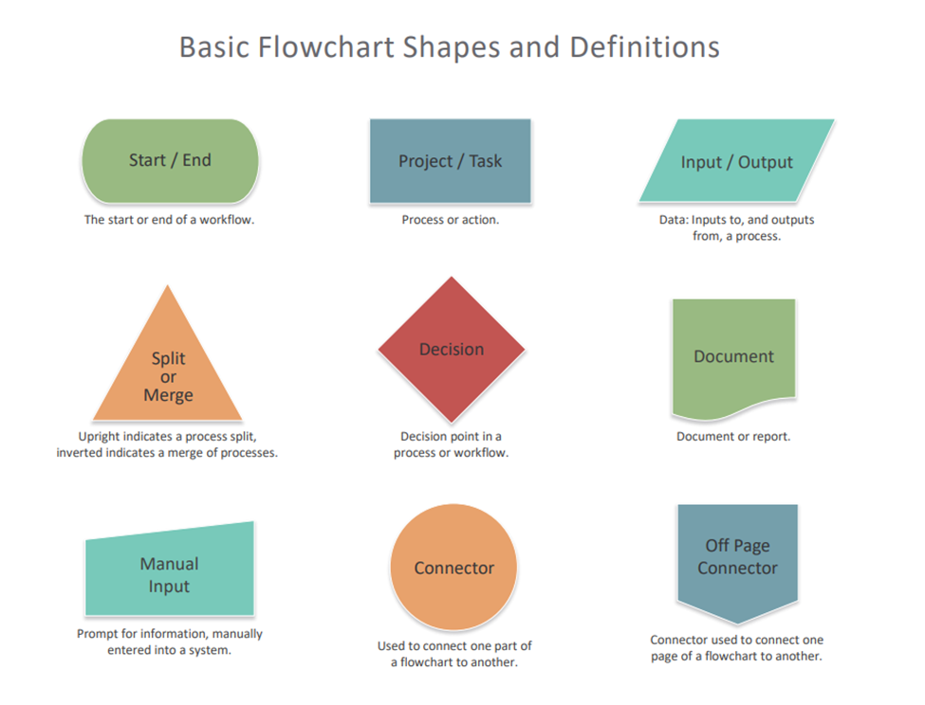

START

DISPLAY  
“WELCOME TO THE GAME OF IMPERIUM”

*MENU SCREEN*

Did the  
Player selected “Start the Game”?

NO

YES

Player’s Input: Username

Player’s Input: Number of Rounds

Off Page  
Connector

Off Page  
Connector

START THE GAME

DISPLAY THE  
CURRENT ROUND’S BATTLEFIELD

DISPLAY THE  
CURRENT ROUND’S BATTLEFIELD

PROCESSING THE  
SELECTED POTION’S EFFECTS

THE PLAYER USES A POTION

Player’s  
Decision

THE PLAYER ATTACKED AN ENEMY

PROCESSING  
THE ACTIVE  
“PLAYER ATTRIBUTES”

Stun Effect?

Life Steal?

Critical Hit?

YES

YES

YES

NO

NO

NO

+% Player Dmg

The Stunned Enemy will be excluded from being selected to attack the Player.

+% Player HP  
-% Enemy HP

UPDATING THE  
PLAYER’S STATS AND THE SELECTED ENEMY’S STATS

Off Page  
Connector

Off Page  
Connector

NO

Selected Enemy’s HP >  
0 HP?

Updating the Selected Enemy’s Stats and its Status to being defeated

YES

A RANDOM ENEMY WILL BE CHOSEN TO ATTACK THE PLAYER

PRINT  
  
“!!! MISSION FAIL !!!”  
“!!! YOU HAVE BEEN CONQUERED !!!”

Player’s HP  
>  
Random Enemy’s Dmg?

NO

YES

FINISH

All Enemies in the Current Round Defeated?

YES

DISPLAY THE  
CURRENT ROUND’S BATTLEFIELD

UPDATING THE CURRENT ROUND AS CLEARED

NO

All Desired Number of Rounds Cleared?

YES

PRINT  
  
“!!! CONGRATULATIONS !!!”  
“!!! YOU HAVE OBTAINED IMPERIUM !!!”

FINISH